**ReadMe**

The unity scene given below contains our 3D Virtual Environment, Interactive Virtual Objects and 3D Manipulation Technique:

3D Manipulation → Assets → Scenes → SampleScene.unity

The Five Interaction States of the 3D Manipulation Technique are:

1. Open – Initial State; no grasp and when trigger button is released, hand.type is Affect.Virtual to let pass through objects
2. Closed – when trigger button is pressed, hand.type is Affect.Physical to create collisions with objects
3. Holding – hand reaches (touches) object and trigger button pressed to hold objects
4. Touching – trigger button pressed and touching object
5. Displace – navigate with object in hand (using steering button and trigger button) to displace from its position

Given below is the corresponding Virtual Hand State Machine Diagram

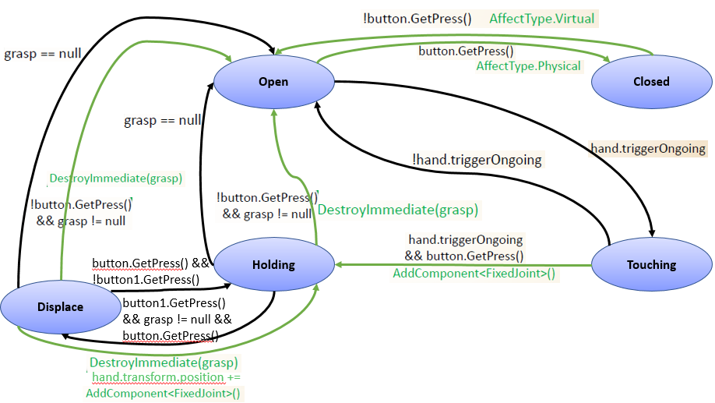

How to use it with the HTC Vive

* The controller joystick is used to control relative direction (forward / backward / left / right) and speed.
* The trigger button required to be pressed to grab/move objects
* One can test the functionalities in this way:
  + OPEN to CLOSED state and vice-versa: the Trigger Button of the VirtualHand is pressed which enables to collide with objects (in CLOSED state) as opposed to passing through them (in OPEN state) and releasing the Trigger Button.
  + Trigger Button of the VirtualHand is pressed and touch the object, to see it moving (TOUCHING)
  + Touch the object with the VirtualHand and Press the Trigger button, move the Hand in all directions, to grab and move the object along with your hand. (HOLDING)
  + Release the Trigger Button to see the object fall from your hand (OPEN)
  + HOLD the object by pressing Trigger Button and press the TouchPad (controller Joystick) in any direction to see the object navigating/ steering in that direction i.e, to DISPLACE it from its actual position. If the Trigger Button is released (OPEN) while in mid-air, you can see the object fall down. On the contrary, if the steering is stopped, its state changes to HOLDING.

These virtual objects within the virtual environment are interactive:

1. *Basket* (Trash Bin)
2. *Alarm Clock* (on *RoundTable* in Bedroom)
3. Green Apples (on the *Dining Table Set* near window – 2 apples *APLLE017, APLLE018* on the table – stationary apple *Box002* and Table)
4. Red Apple, *Orange* (on Kitchen Table – *tbl022*)
5. Books (on *Table_Dolfi* in living room)
6. *Crystal* vase (on the *Dresser*)

To navigate to these objects, we can use the Travel Technique by pressing the Touchpad Button.